**LAB 02**

1. Create a new table Person and insert at least 5 records.

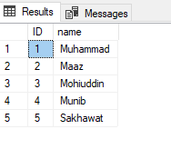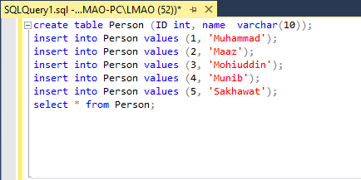

1. Add a new field in the Person table.
2. Modify any field in the Person table.

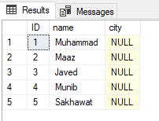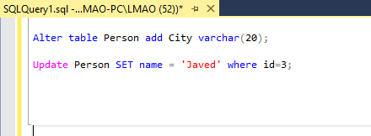

1. Create a new table Customer and insert at least 5 records.

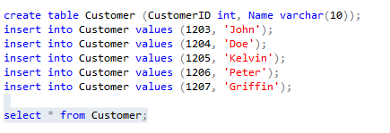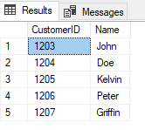s

1. Create a new table Order and insert at least 5 records

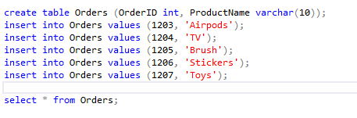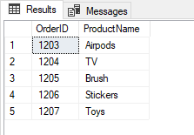

1. Use some constraints in your queries



**LAB 03**

**LAB 04**

**LAB 05**

**LAB 06**

**LAB 07**